Department: Information Technology Engineering  
Course: Computer Graphic

Name: Beun Bunleap

Lecture 02

1. **Introduction**

This assignment focuses on implementing and understanding **2D transformations**, specifically **translation** and **rotation**, using OpenGL. Translation involves moving an object from one position to another, while rotation involves turning an object around a fixed point. Both transformations preserve the shape and size of the object.

1. **Theory**
   1. **Translation**

**Definition:** Translation moves an object from one position to another by adding displacement values (tx, ty) to its coordinates.

**Matrix Representation:**

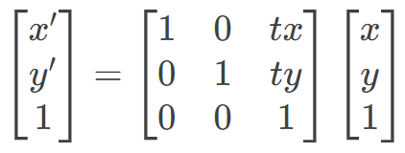

* (x, y): Original position
* (x’, y’): New position after translation
* tx: Displacement along the x-axis.
* ty: Displacement along the y-axis.

**Key Points:**

* Translation is additive.
* Order of transition does not matter.
* Reversible by using negative displacement values.
  1. **Rotation**

**Definition:** Rotation turns an object around a fixed point (usually the origin) by a specified angle 0.

**Matrix Representation:**

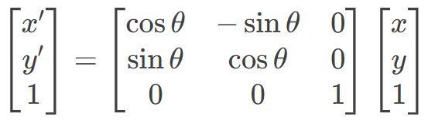

* θ: Rotation angle (positive for counterclockwise, negative for clockwise).
* (x, y): Original position.
* (x', y'): New position after rotation.

**Key Points**:

* Rotation is around the origin (0, 0).
* Order of transformations matters when combining with other transformations.
* A full rotation is 360°.

1. **Implementation**

**3.1 Translation Demo**

The provided code implements a translation demo using OpenGL. Below is the explanation of the code:

|  |  |  |
| --- | --- | --- |
| |  |  | | --- | --- | | 1  2  3  4  5  6  7  8  9  10  11  12  13  14  15  16  17  18  19  20  21  22  23  24  25  26  27  28  29  30  31  32  33  34  35  36  37  38  39  40  41  42  43  44  45  46  47  48  49  50  51  52  53  54  55  56  57  58  59  60  61  62  63  64  65  66  67  68  69  70  71  72  73  74  75  76  77  78  79  80  81  82  83  84  85  86  87 | #include <GL/glut.h>  #include <math.h>  #include <stdio.h>  *// Global variables for translation*  float translateX = 0.0f;  float translateY = 0.0f;  *// Initialize window and OpenGL settings*  void init() {  glClearColor(1.0f, 1.0f, 1.0f, 1.0f); *// White background*  glMatrixMode(GL_PROJECTION);  glLoadIdentity();  gluOrtho2D(-10.0, 10.0, -10.0, 10.0);  }  *// Draw a colored square*  void drawSquare() {  glBegin(GL_POLYGON);  glColor3f(1.0f, 0.0f, 0.0f); *// Red*  glVertex2f(-1.0f, -1.0f);  glVertex2f(1.0f, -1.0f);  glVertex2f(1.0f, 1.0f);  glVertex2f(-1.0f, 1.0f);  glEnd();  }  *// Draw coordinate axes*  void drawAxes() {  glColor3f(0.0f, 0.0f, 0.0f); *// Black*  glBegin(GL_LINES);  *// X-axis*  glVertex2f(-10.0f, 0.0f);  glVertex2f(10.0f, 0.0f);  *// Y-axis*  glVertex2f(0.0f, -10.0f);  glVertex2f(0.0f, 10.0f);  glEnd();  }  *// Display function*  void display() {  glClear(GL_COLOR_BUFFER_BIT);  *// Draw axes*  drawAxes();  *// Apply translation and draw square*  glPushMatrix();  glTranslatef(translateX, translateY, 0.0f);  drawSquare();  glPopMatrix();  *// Display current translation values*  glColor3f(0.0f, 0.0f, 0.0f);  glRasterPos2f(-9.5f, 9.0f);  char buffer[50];  sprintf_s(buffer, sizeof(buffer), "Translation: (%.1f, %.1f)", translateX, translateY);  for (char* c = buffer; *c != '\0'; c++) {  glutBitmapCharacter(GLUT_BITMAP_HELVETICA_18, *c);  }  glutSwapBuffers();  }  *// Keyboard control*  void keyboard(unsigned char key, int x, int y) {  switch (key) {  case 'w': translateY += 0.5f; break; *// Move up*  case 's': translateY -= 0.5f; break; *// Move down*  case 'a': translateX -= 0.5f; break; *// Move left*  case 'd': translateX += 0.5f; break; *// Move right*  case ' ': *// Reset position*  translateX = 0.0f;  translateY = 0.0f;  break;  }  glutPostRedisplay();  }  int main(int argc, char** argv) {  glutInit(&argc, argv);  glutInitDisplayMode(GLUT_DOUBLE | GLUT_RGB);  glutInitWindowSize(800, 800);  glutCreateWindow("Translation Demo");  init();  glutDisplayFunc(display);  glutKeyboardFunc(keyboard);  glutMainLoop();  return 0;  } | |

* **Translation Demo**:
  + The square moves smoothly in the specified direction when pressing W, A, S, or D.
  + The position resets to the origin when pressing the spacebar.

1. First screen

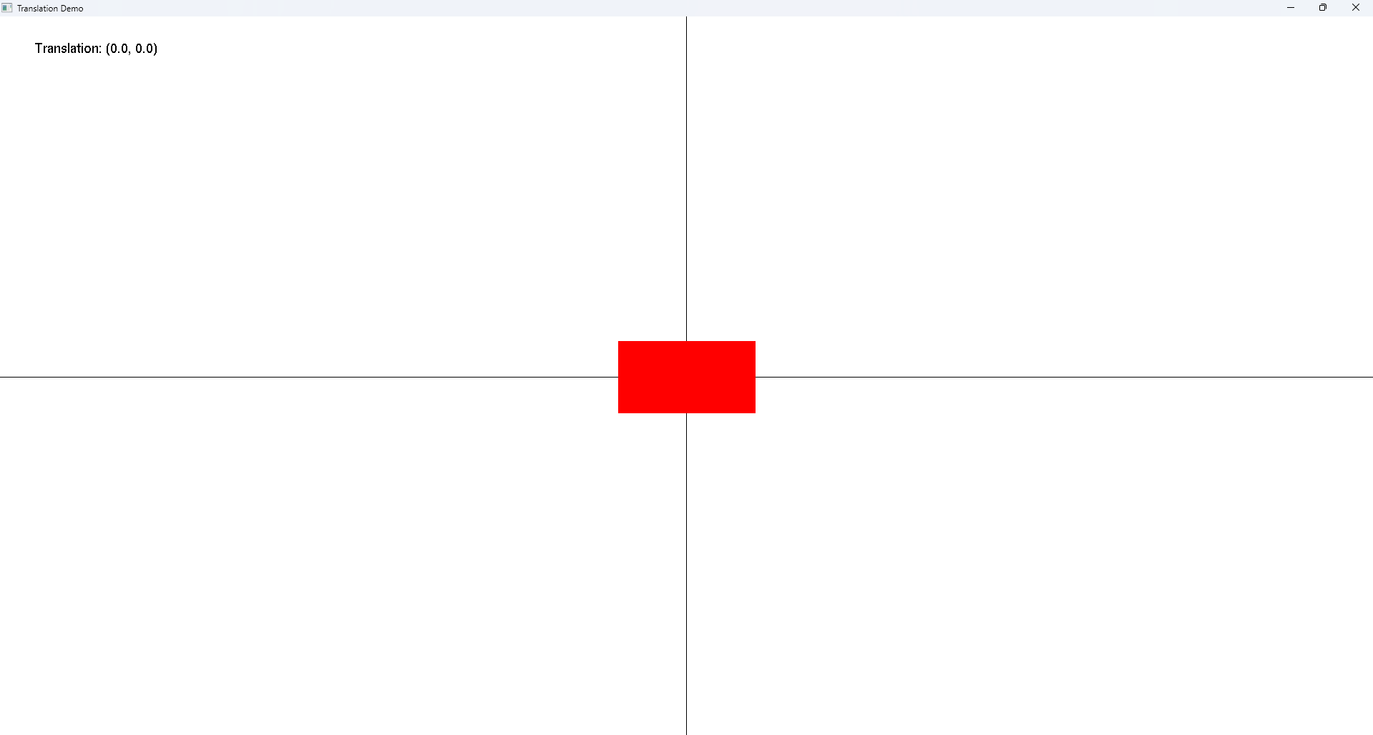

1. Click on **A**

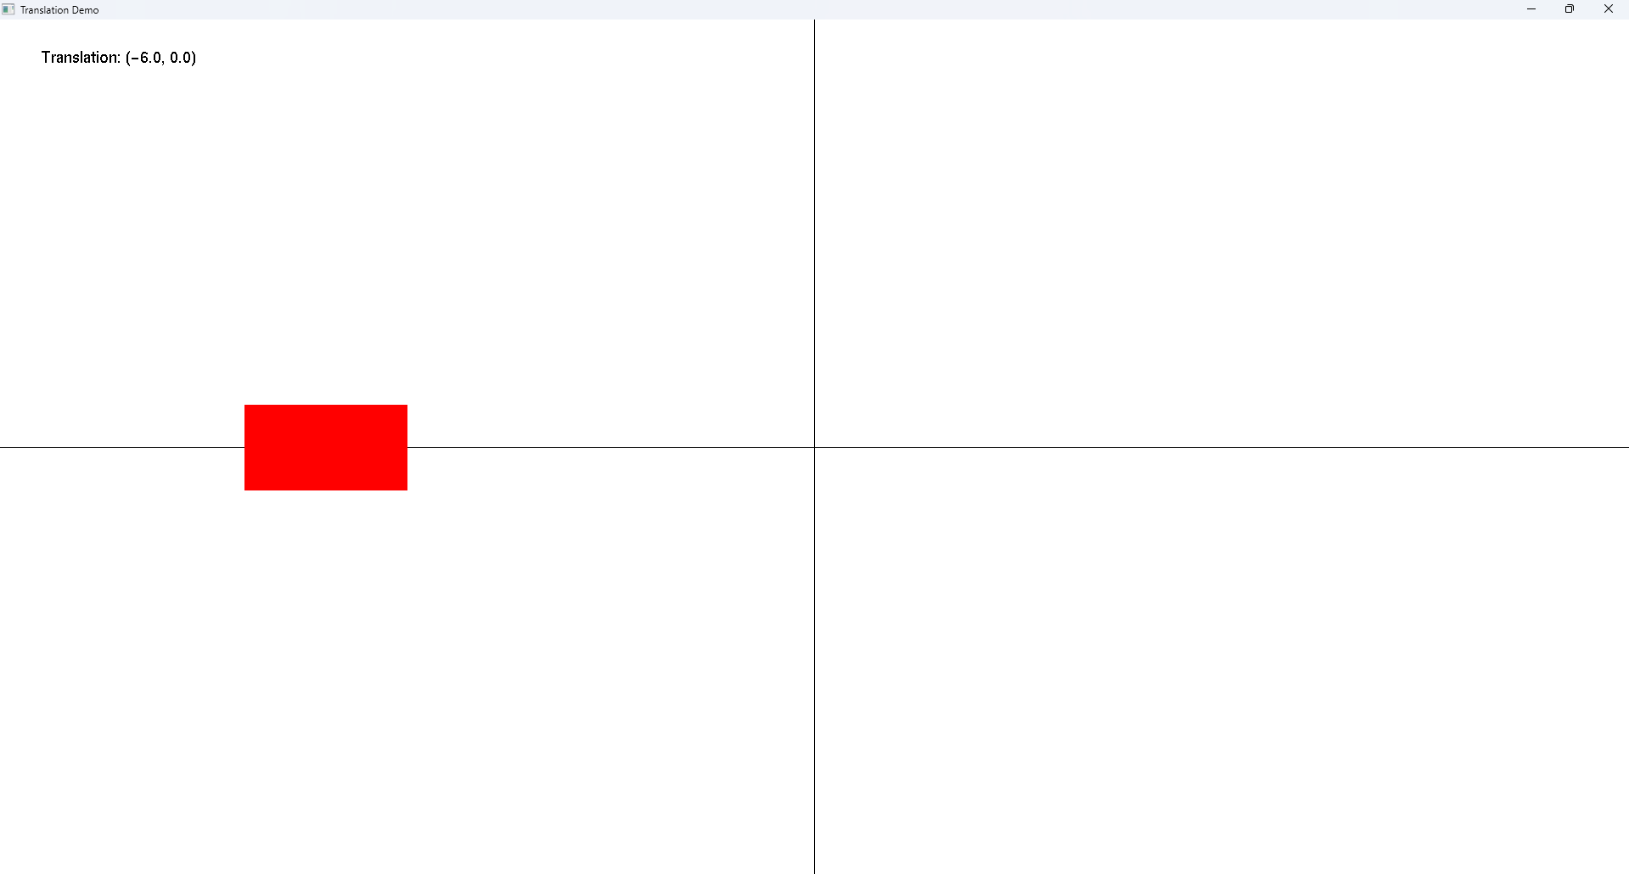

1. Click on **W**

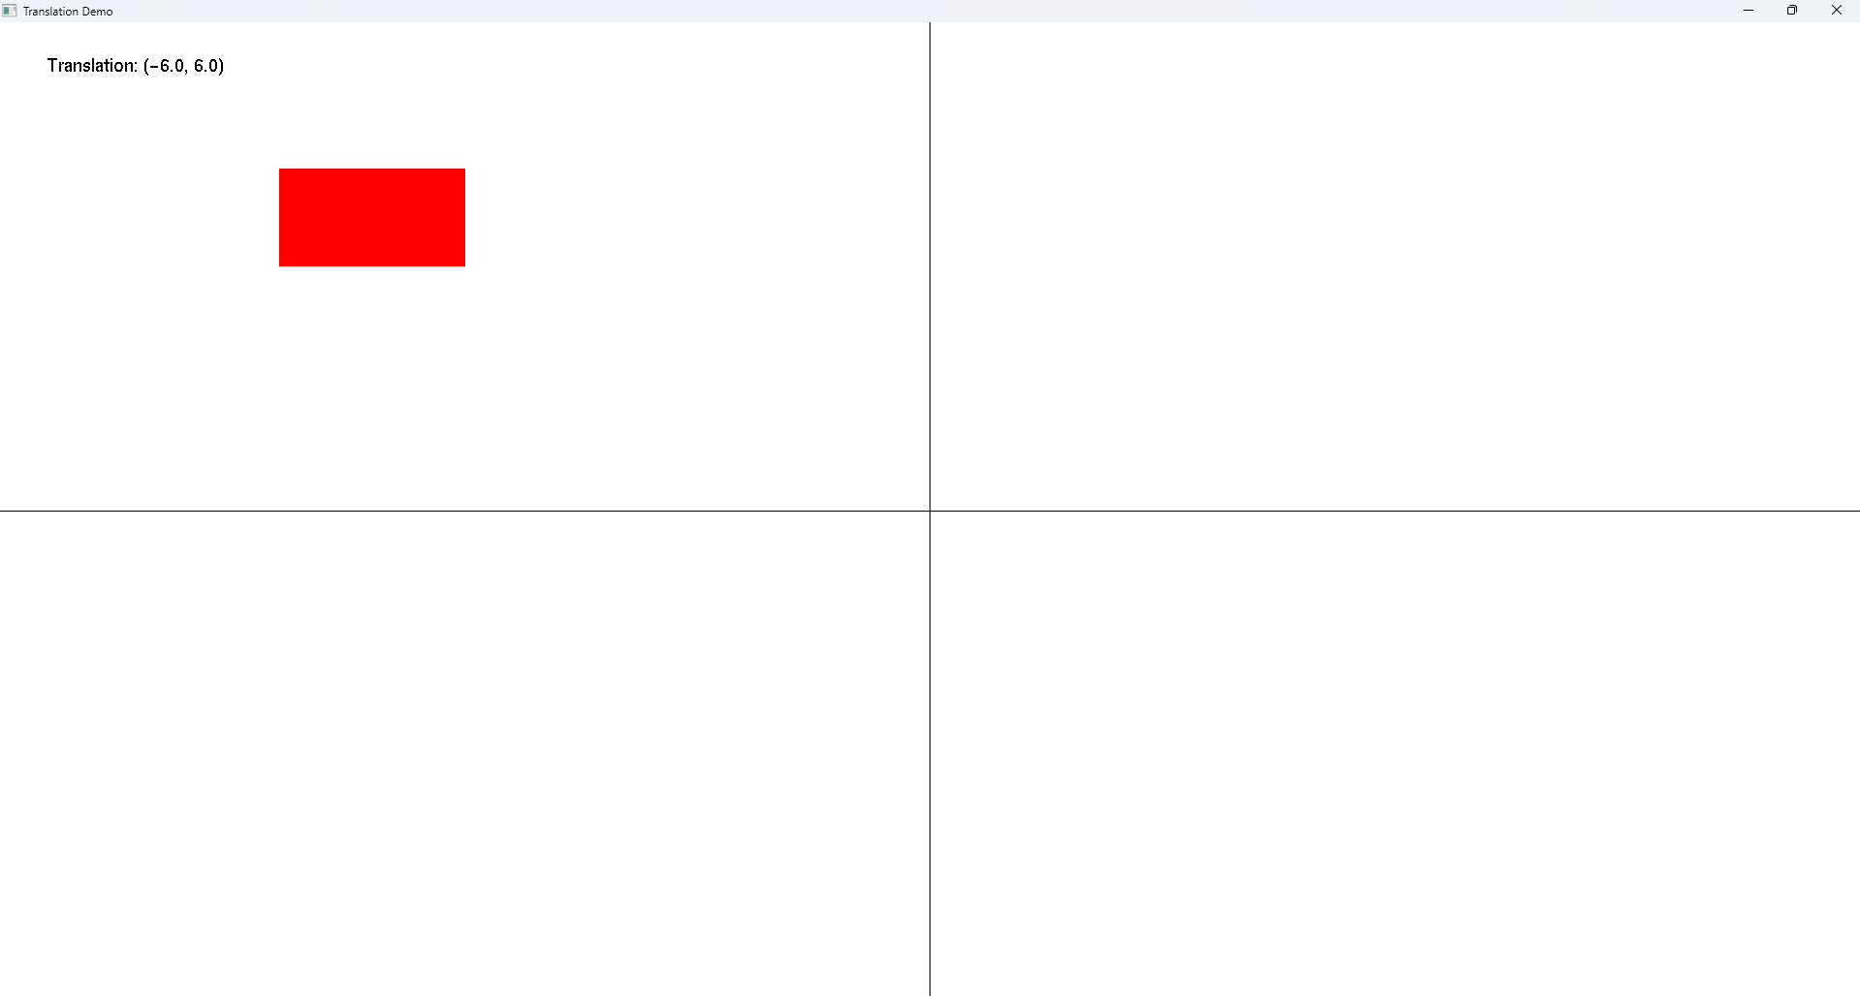

1. Click on **D**

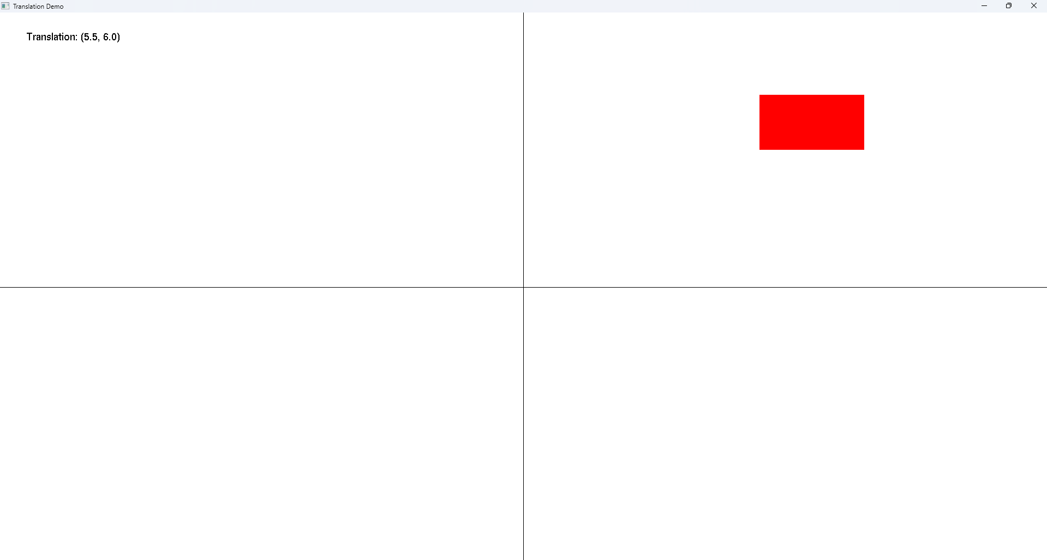

1. Click on **S**

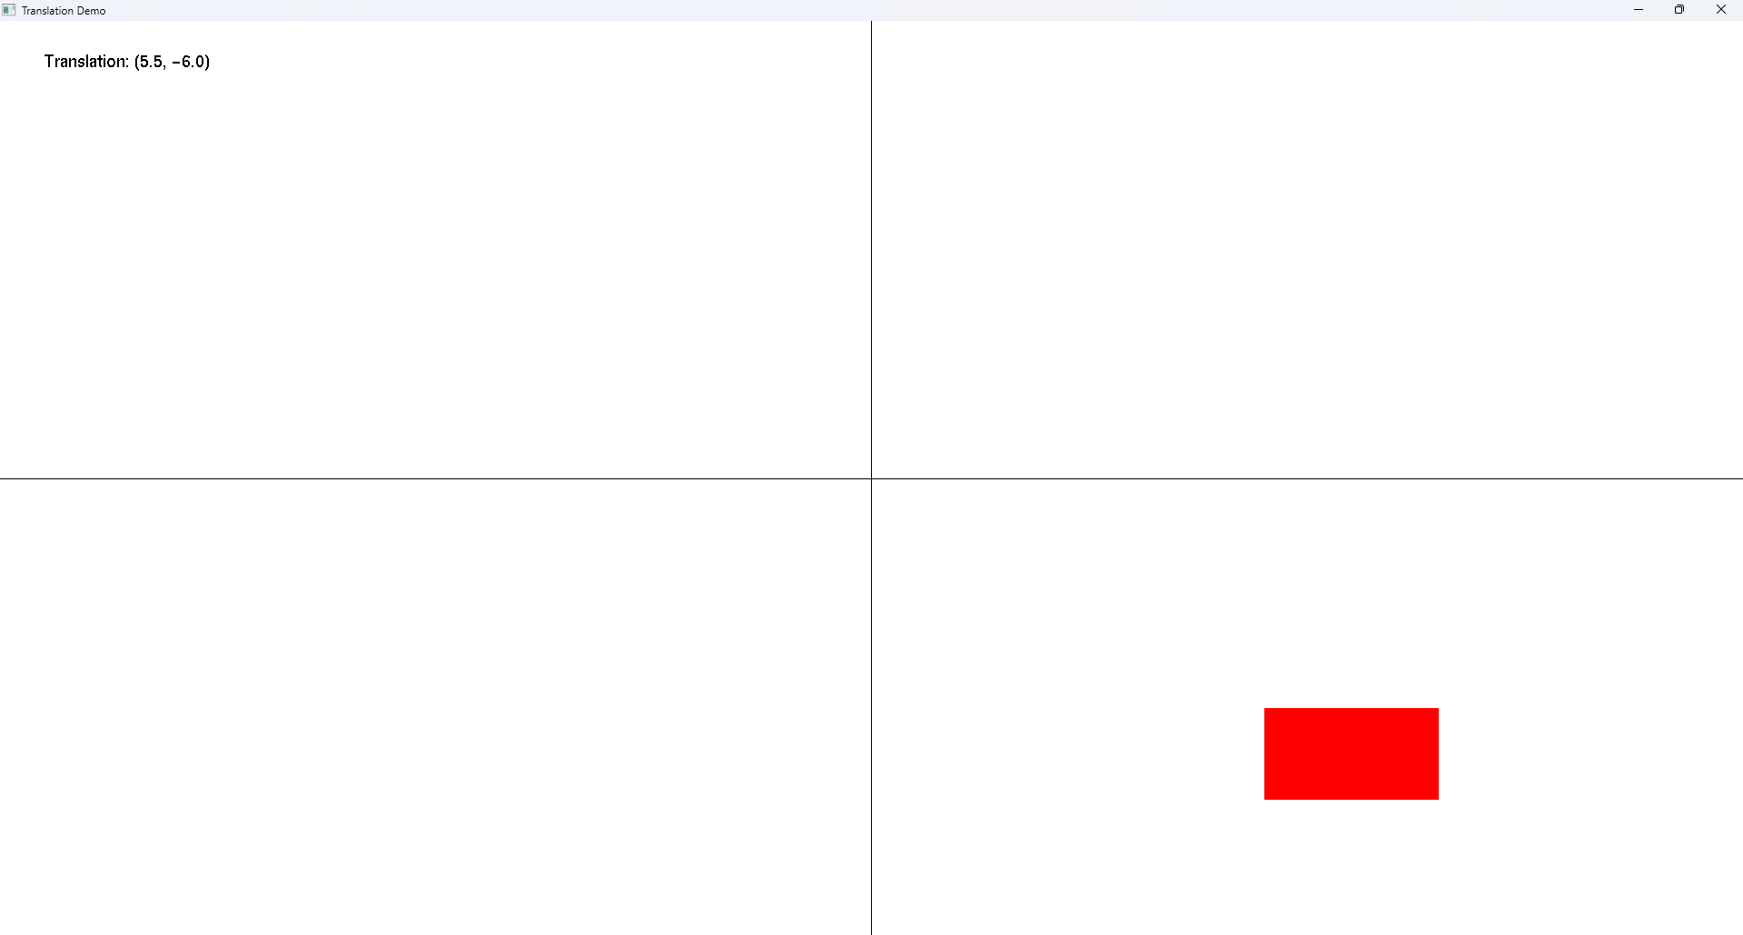

1. Click on **Space**



**3.2. Rotation Demo**

The provided code implements a rotation demo using OpenGL. Below is the explanation of the code:

|  |  |  |
| --- | --- | --- |
| |  |  | | --- | --- | | 1  2  3  4  5  6  7  8  9  10  11  12  13  14  15  16  17  18  19  20  21  22  23  24  25  26  27  28  29  30  31  32  33  34  35  36  37  38  39  40  41  42  43  44  45  46  47  48  49  50  51  52  53  54  55  56  57  58  59  60  61  62  63  64  65  66  67  68  69  70  71  72  73  74  75  76  77  78  79  80  81  82  83  84  85  86  87  88  89  90  91  92  93  94  95 | #include <GL/glut.h>  #include <math.h>  *// Global variables for rotation*  float rotateAngle = 0.0f;  bool autoRotate = false;  *// Initialize window and OpenGL settings*  void init() {  glClearColor(1.0f, 1.0f, 1.0f, 1.0f); *// White background*  glMatrixMode(GL_PROJECTION);  glLoadIdentity();  gluOrtho2D(-10.0, 10.0, -10.0, 10.0); *// Set coordinate system*  }  *// Draw a triangle with different colored vertices*  void drawTriangle() {  glBegin(GL_TRIANGLES);  glColor3f(1.0f, 0.0f, 0.0f); *// Red*  glVertex2f(-1.0f, -1.0f);  glColor3f(0.0f, 1.0f, 0.0f); *// Green*  glVertex2f(1.0f, -1.0f);  glColor3f(0.0f, 0.0f, 1.0f); *// Blue*  glVertex2f(0.0f, 1.0f);  glEnd();  }  *// Draw rotation center indicator*  void drawCenter() {  glPointSize(5.0f);  glColor3f(0.0f, 0.0f, 0.0f); *// Black*  glBegin(GL_POINTS);  glVertex2f(0.0f, 0.0f);  glEnd();  }  *// Draw coordinate axes*  void drawAxes() {  glColor3f(0.5f, 0.5f, 0.5f); *// Gray*  glBegin(GL_LINES);  glVertex2f(-10.0f, 0.0f);  glVertex2f(10.0f, 0.0f);  glVertex2f(0.0f, -10.0f);  glVertex2f(0.0f, 10.0f);  glEnd();  }  *// Display function*  void display() {  glClear(GL_COLOR_BUFFER_BIT);  drawAxes(); *// Draw axes*  drawCenter(); *// Draw center point*  glPushMatrix();  glRotatef(rotateAngle, 0.0f, 0.0f, 1.0f); *// Apply rotation*  drawTriangle(); *// Draw triangle*  glPopMatrix();  glutSwapBuffers();  }  *// Keyboard control*  void keyboard(unsigned char key, int x, int y) {  switch (key) {  case 'r': rotateAngle += 5.0f; break; *// Rotate clockwise*  case 'R': rotateAngle -= 5.0f; break; *// Rotate counter-clockwise*  case ' ': rotateAngle = 0.0f; break; *// Reset rotation*  case 'a': autoRotate = !autoRotate; break; *// Toggle auto-rotation*  }  *// Keep angle between 0 and 360*  if (rotateAngle >= 360.0f) rotateAngle -= 360.0f;  if (rotateAngle < 0.0f) rotateAngle += 360.0f;  glutPostRedisplay(); *// Redraw the scene*  }  *// Timer function for auto-rotation*  void update(int value) {  if (autoRotate) {  rotateAngle += 2.0f;  if (rotateAngle >= 360.0f) rotateAngle -= 360.0f;  glutPostRedisplay();  }  glutTimerFunc(16, update, 0); *// ~60 FPS*  }  int main(int argc, char** argv) {  glutInit(&argc, argv);  glutInitDisplayMode(GLUT_DOUBLE | GLUT_RGB);  glutInitWindowSize(800, 800);  glutCreateWindow("Rotation Demo");  init();  glutDisplayFunc(display);  glutKeyboardFunc(keyboard);  glutTimerFunc(0, update, 0);  glutMainLoop();  return 0;  } | |

1. First Screen

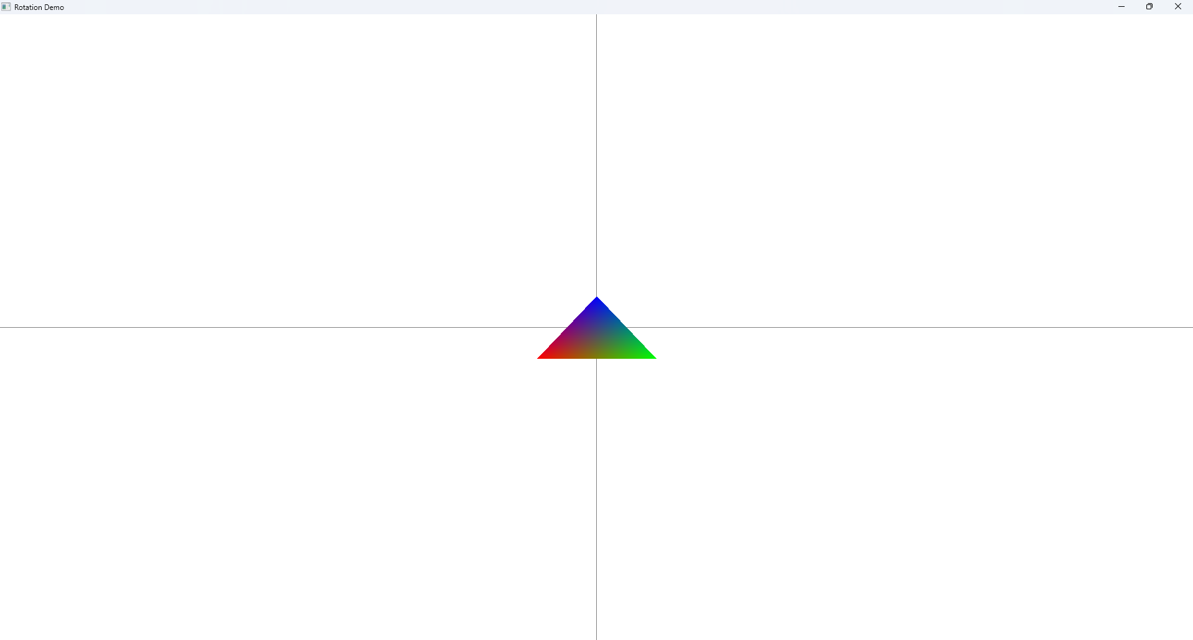

1. Click on **R** or **Shift + R**

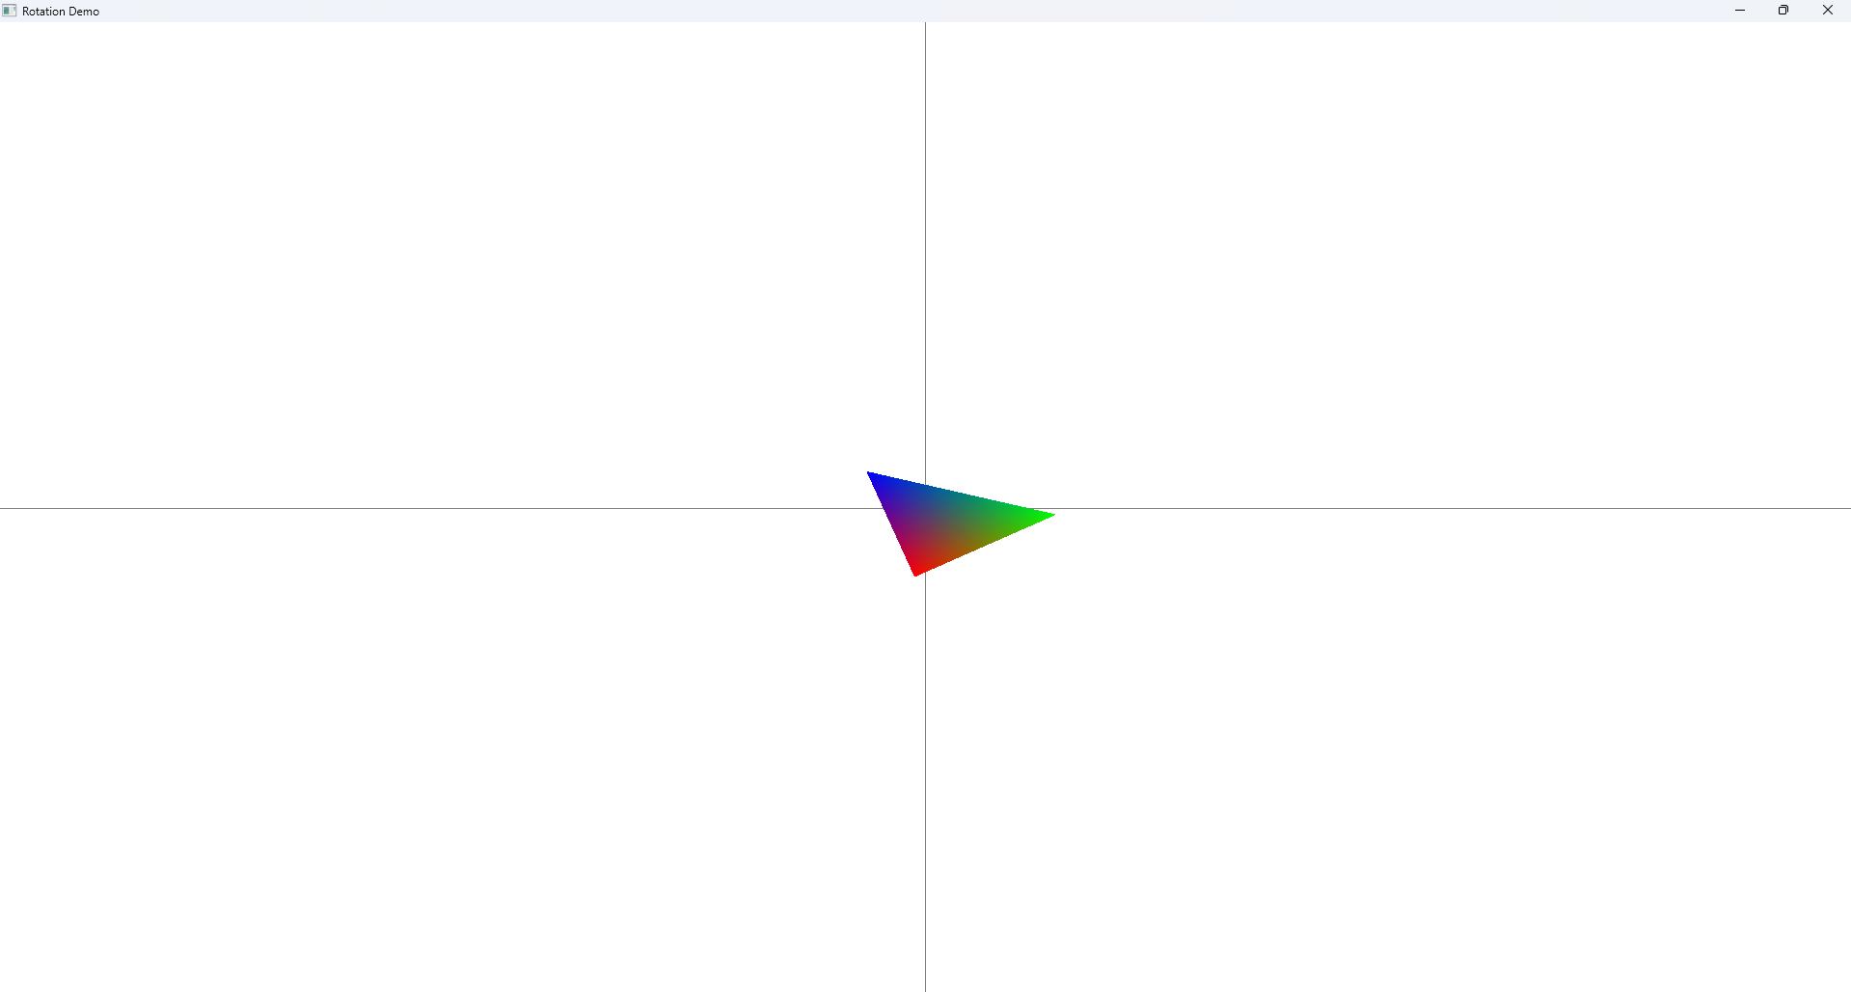

1. Click on **A (it will rotate as loop auto, and when click on A again it will stop)**

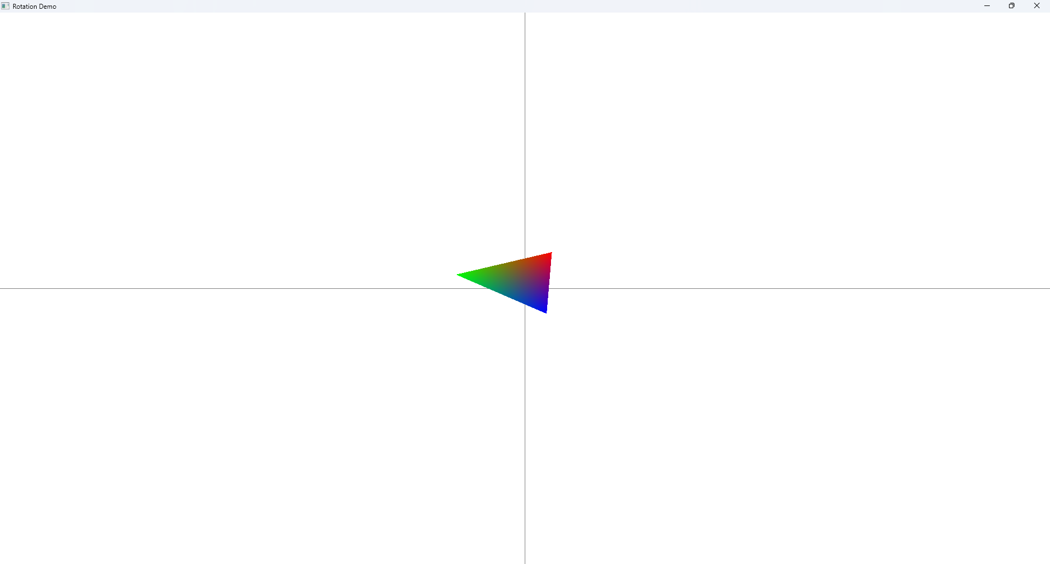

**Rotation Demo**:

* The triangle rotates clockwise or counter-clockwise when pressing R or Shift+R.
* Auto-rotation can be toggled with the A key.
* The rotation resets to 0° when pressing the spacebar.